Possessive Subject, Radical: Whose School is This?
The School Without Walls and the Elizabeth Cleaners Street School

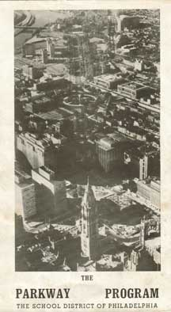

by Sasha Moniker
Artist, Hysteric, Writer, and “Failing Teacher”

Dungeons and Dragons
My teaching, I found out this year, is not “effective,” at least not according to the forms my students filled out in pencil at the end of last semester. I received this news as a shameful smear, as if I had been going around with shit on my face, or caught in some vile act, and even though I knew how flawed these measurements are, these perilously low graphite-filled bubbles could cost me my job. I wanted so badly to teach for years before getting this position that promised, among other things, the opportunity to work with the same students for more than a semester at a time. My agenda, however, as I understand more clearly now, only barely matches the agenda of the institutional hierarchy in which I found myself. Despite the high-sounding ideal of self-governance, I found I was only slightly above the students and their long suffering parents in the service-pyramid, and definitely below the Equipment Manager, the Department Chair, The College Dean, the Provost, Chancellor, Board of Regents, and then State Legislature and Governor, and more likely than not, a handful of corporate lobbyists. This would explain the fact that girl’s softball and aviation technologies are the favored programs at one university I have been reading about. It’s all rather medieval, so much that, when I explained the process of getting tenure to a younger friend, she said, “Its just like Dungeons and Dragons.” At least I do stand level with my colleagues, who also live with these circumstances, and with whom I share the occasional satisfaction that something embodied in our beautiful democratic process and our sincere appreciation of our students, even if only occasionally, takes root.

Oh Yes, the Agenda
School is a system through which “knowledge” is delivered in packets called “courses.” An effective course delivers enough knowledge to the student to be able to get on to the next course and the next and the next. Like courses, the separation of the disciplines aids in this program. Part of the system, as well, at least in the public school sector, is also to deliver “raw material” to the plant, or “the school,” to be manufactured or finished. This student, fresh out of high school or community college, is ready to be turned into a college graduate, and to “refine” this material requires a host of other supplies, from paper towels to corn sugar to loans to soda machines to computer software and copy paper and airplane tickets and so on, things that, in the process of manufacturing the graduate, also fuel the economy. No, this is nothing new, but it is surprising how little has changed since there has certainly been a lot of criticism over the years of an educational system that reduces learners to numbers. Of course, there are numbers and there are numbers. The objective is to accomplish these feats, these transfers, deliveries, and burnishings of the rough edges, in order to roll things off the assembly line efficiently. And students, upon whose backs this burdensome debt falls, needs must find themselves agreeing with a protocol of efficiency, regardless of what stands in for “education.” Perhaps needless to say, the aptitude for critical thinking, or reflexive subjectivity, or civic awareness, and other rather-difficult-to-list-in-a-resume-form-skills are only included with this ‘product,’ at best, haphazardly.

The Parkway High School of Philadelphia, also known as the School Without Walls, first opened in 1969 and graduated its first class in 1970. While there were spaces allocated for a homeroom-like situation, called the tutorial, where students met daily to discuss school business and review basic math skills, the school itself had no building, famously using the whole of Philadelphia as its campus. Students had classes in City Hall, (taught by the “Committee of Seventy,” a non-partisan government watchdog organization), the Art Museum, the Public Library and the Franklin Institute. Besides regular teachers, students were taught by professionals in their fields; artists, lawyers, diplomats, scientists. By relying on already existing civic institutions and the private and non-profit sector’s generosity, the school was able to eliminate spending the enormous sums required to build and maintain a school building. For the financial reasons alone, students today need schools without walls.

“America has never had an educational system worthy of itself. After pioneering a continent, developing new forms of social and political organization, absorbing countless immigrants and bringing technology into a close relationship with human life, it is nevertheless true that Americans have adopted principles and practices of education belonging to another age and imported from another society. The Parkway Program tries to provide a mode of education in keeping with the major traditions of American life.”

With these words, John Bremer and Michael von Moschzisker dedicate their 37 year-old book about Philadelphia’s Parkway School. From the perspective of today, when our governing process is appearing as defective as ever, it is not clear what exactly they mean by the “major traditions of American life” in this statement, both optimistic and riddled with problems. In the introduction that follows, however, they elaborate upon the problems, such as the historic and continuing exclusion of women and people of color as full members of society. But then they detail what they think was so great, and what they hope to create at Parkway.

This is the remnant of the commune, the small town, the frontier village characterized by lack of specialization, the expectation of full participation in civic life, of internal cooperation and the opportunity for self-governance. In a stratified society where high school is a holding tank for youth, Parkway’s utopianism aimed for a pre-industrial moment of social inclusion, or perhaps for total revolution, by striving to imbue in a public institution a participatory democracy in which any student could capably speak to the press, lead a discussion, or expect the community around them to respond rationally and creatively to their initiatives and actions.

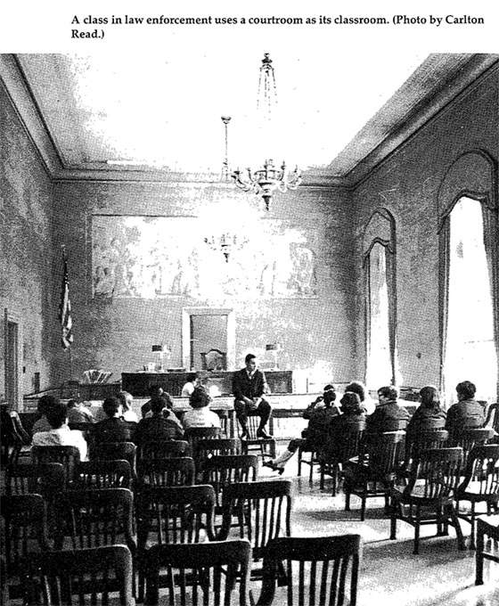

The School without Walls was a public school that accepted many of the young people for whom there was really no place anyway, who had already suffered debasement at the hands of parents, other school officials, welfare officers, truant officers, police officers. Parkway offered immunity to truants and “misbehavers” and instead of operating like a waiting room, in which students become accustomed to confinement until the time is right to release them on the assembly line, the school most radically unleashed these young people upon the city itself, asking them to recognize it and use it as their own. While the school still exists, the radical agenda of self-governance capitulated early on to local electoral politics and conservativism. Among the complaints leveraged against the school in a flurry of editorials was the specter of up to 2400 youth roaming the grand civic space of Philadelphia’s Benjamin Franklin Parkway. Writing for the future, Bremer emphasizes in his book that the principles of Parkway are more important than its specific history;
“Our lives are inseparable from the city, just as the city is essentially its citizens; all of its citizens. This means that education and politics are inseparable activities and that every political act is an educational act and that every educational act is a political act. We should not want it any other way, for if politics is concerned with power, education is concerned with love, and one without the other is corrupting. Power without love produces tyranny, love without power produces anarchy. Starting from different points of view, educators and politicians alike have to reconcile, to bring into harmony these two forces, and the future of all of us depends on the accomplishment of this difficult task.”

Hatred of School
The law requires young people to attend school. A large number of the first classes at Parkway were potential or current dropouts. I want to know what my students really think about their compulsory education. I wonder how many of them were miserable in high school, and if so, why they continue into college. I suspect it is because for the first time in their lives, their family is able to send them; this is their fate. I suspect they feel there is no other choice. As good kids, they do not complain, and there is a good chance university will offer something different. The personal narratives of students attending Parkway and ECSS emphasize their boredom and other forms of suffering at their former high schools. It seems that there is still this pain today, and it is a taboo subject, or perhaps students are calloused, or scared. Parkway teacher describes how uncomfortable many students were about speaking in a group at first. Only the teacher with enormous emotional protection and agility might get the students to talk: What do you want? I don’t know. I want to be a thing, a thing in the world, a name of a career. Why do you want this? I don’t know. I like thing. I don’t know. What are you afraid of? Getting sick. Not having enough money. What do you care about? Who are you?

Students Self-Governance
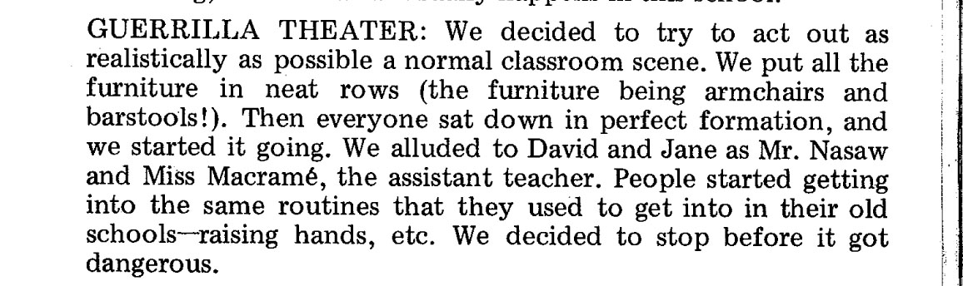
(from the notebook of Pablo Conrad)

Elizabeth Cleaners Street School was an independent high school started on the upper West Side in New York by a small group of teenagers attending various private and public schools around the City in 1969. The students, ranging from age 13 to 17, were miserable in their schools, either because of the small and large kinds of cruelty perpetuated by youth, or because of the boredom of routine or authoritarianism. These students perhaps were not sure what they cared about at first, but they were certain it wasn’t going on in their traditional high school curriculum. Their parents were largely educated, progressive people who supported this initiative and actively worked to make it happen. Former teacher Jack Litekwa writes about how after the first couple of organizing meetings, the students calmly, politely took over the proceedings, proclaiming that it is their school, and they are going to make the decisions as much as they can.
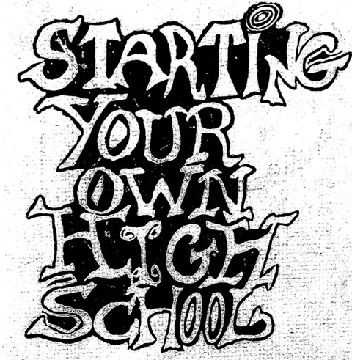

They decided to pay two teachers, and get volunteers to teach the rest of the classes. They acquired a space through Operation Move In, a local non-profit that helped homeless people squat vacant buildings. Thus Elizabeth Cleaners Street School started its life in a squatted storefront under the sign from which it drew its name. The first classes offered were plumbing (how to install a toilet) and urban studies, conducted through field-work in the neighborhood where they were located. They raised money through bake sales, benefit concerts, and any street fair at which they could sell records and second hand goods. The school was open to anyone who wished to join, but the stayed at around 20 students of different grades and ages. Although they tried to get more students from the primarily black and Puerto Rican neighborhood, they had to admit that an unaccredited high school might not be an attractive offer for a student already at risk of not getting into college. Students interviewed and hired the teachers, decided what they wanted to study and how, taught classes themselves, managed conflicts and difference, and constantly discussed, and consciously addressed the dynamics of their cooperative management, and their relationships to power and authority.

Education as Uncertainty
After numerous requests for articles and interviews by journals and scholars, the students decided to write their own book as a venture for earning money. The book is full of personal narratives, journal entries and sketches. It was revelatory to discover “Starting Your Own High School” in the library stacks because the stories I read in here came the closest to my experience of teaching before I was bubbled to the bottom of the teaching curve at my current institution. In this book, students, teachers and parents write about school as a whole process, one that includes the question of what a school is and what is it for. There is constant uncertainty as to what exactly will happen next, whether this course should go on, or stop now. Courses were of irregular durations, sometimes stopping after a few weeks, and sometimes continuing the whole year, with students and teachers sharing the responsibility of deciding when to stop, based on questions of urgency or of whether you know enough for now. The traditional dynamic of student as recipient of the teacher’s knowledge was replaced by the question of what kind of experience will be valuable when studying a particular subject. Fundamental to such a situation is the premise, shared by ECSS and Parkway, that teachers are students and students are teachers. While this operational strategy is exciting for someone like me, these transitional uncertainties of how “learning” will occur can be frightening for those accustomed to the assumption that education can be packaged like a product.

Elizabeth Cleaners was a school organized by a specific group of students were interested in clarifying, first, their relationships to authority and institutions of education, and second, in deciding for themselves what they wanted to study and the kind of intensity of experience they wanted to have in high school. By the end of the first year, student writings reflect a change in attitude; sometimes a new ability to be scholars. And the school ended in much the same organic fashion as it formed. David Nasaw, one of the paid teachers writes, “The school closed down because the students in it had no wish to create an institution that lived beyond them. They never quite articulated it this way, but it was clear that they were not interested in recruiting new students or in fundraising for the future. So when the last of the original founding students left, the school died a natural death. No tragedy here, no pain, just an institution that had served its purpose and departed.”
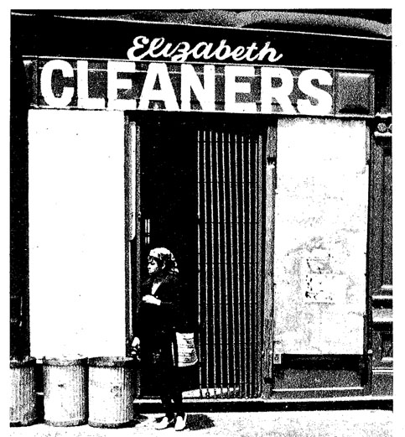

John Bremer, The Parkway Program (Introductory Brochure, 1969)
John Bremer and Michael von Moschzisker, The School Without Walls: Philadelphia’s Parkway Program, New York: Holt, Rinehart and Winston, Inc., 1971p. 140.
Bremer and Moschzisker, p. 284. From “Director’s Statement at Second Student Drawing,” Friday, 13 June 1969.
Bremer and Moschzisker, p. 149.
Derrick Jensen, Walking on Water: Reading, Writing and Revolution, about risk taking in classrooms.
Elizabeth Cleaners Street School, Starting Your Own High School, New York: Westside Project for Progress Inc., Random House, 1972.
From private email from David Nasaw.

